Pharmacy Management System
Low Level Design (LLD)

Backend — C# / ASP.NET Core 6 / SQL Server
DOCUMENT APPROVAL

Approvers of this document

Name | Department | Role | Signature | Date
 |  | Solution Architect
 |  | Technical Lead
 |  | Developer

DOCUMENT CHANGE HISTORY

Document  Version # | Author | Date | Description
1.0 | Development Team | 03/09/2026 | Pharmacy Management System LLD

Table of Contents

1.0 Document Purpose...........................................................................................4
2.0 Intended Audience ............................................................................................4
3.0 Project Background, Objective(s).................................................................4
3.1 Project Background........................................................................................4
3.2 Project Objective ...........................................................................................4
4.0 Design Pattern.................................................................................................5
5.0 Solution Diagram............................................................................................5
6.0 Solution Steps..................................................................................................6
7.0 Classes/function name.....................................................................................10
8.0 Validations......................................................................................................14
9.0 Data model/Tables..........................................................................................15
10.0 API Canvas.....................................................................................................17
11.0 Env variables .................................................................................................18
12.0 Integrations...................................................................................................18
13.0 .NET Hosting / Infrastructure......................................................................18
14.0 HTTP Status Code........................................................................................18
15.0 Unit Testing ...................................................................................................19
16.0 Request .........................................................................................................19
17.0 Response........................................................................................................20

1.0 Document Purpose
This document describes the low level backend design for the Pharmacy Management System. It translates the Pharmacy Management System HLD into an implementation design using C#, ASP.NET Core Web API, Entity Framework Core, SQL Server and RabbitMQ. The solution follows a microservices architecture with separate User/Auth, Order and Supplier-Inventory services.

2.0 Intended Audience
This document is intended as a reference for the stakeholders involved in the Pharmacy Management System technical architecture and implementation.

Role | Nature of Engagement
Product Owner / SME | Validate that the backend design supports the pharmacy business capabilities.
Business Analyst | Validate business rules, workflows and user responsibilities.
Solution Architect | Review service boundaries, API design, persistence and integration approach.
Developer | Use the LLD as the implementation guide for C#/.NET backend development.
QA / Test Engineer | Use API contracts, validations and test cases to prepare functional and unit tests.
Database Developer | Implement and review SQL Server schema, keys, indexes and constraints.

3.0 Project Background, Objective(s)

3.1 Project Background
The Pharmacy Management System has two users: Admin and Doctor. The Admin is the main operator of the pharmacy and manages drugs, suppliers, inventory, doctor orders, order verification, picked-up orders and sales reports. The Doctor can register/login, view available drugs and place orders. These business capabilities are defined by the HLD.

3.2 Project Objective
The backend objective is to expose REST/JSON business capabilities through .NET microservices, authenticate users, enforce Admin/Doctor authorization, manage drugs and suppliers, process doctor orders, verify valid orders, complete pickup, update inventory and generate sales reports.
• Implement the HLD microservice areas using C# and ASP.NET Core Web API.
• Persist each microservice's data in its own SQL Server database using Entity Framework Core.
• Use JWT-based authentication and role-based authorization.
• Use RabbitMQ for asynchronous order events between microservices.
• Keep APIs, validations, exception handling and tests simple enough for implementation during the training project.

4.0 Design Pattern

1 | REST API | HTTP verbs and JSON payloads expose the business operations of each microservice.
2 | Microservices Architecture | User/Auth, Order and Supplier-Inventory capabilities are implemented as separate ASP.NET Core services.
3 | Layered Architecture | Each service uses Controller → Service → Repository/EF Core responsibilities.
4 | Repository Pattern | Database access is isolated behind repository classes where it improves clarity.
5 | Dependency Injection | ASP.NET Core dependency injection supplies services and repositories to controllers.
6 | DTO Pattern | Request and response DTOs are separated from EF Core entity classes.
7 | JWT + Role Authorization | JWT claims identify the user and role; Admin-only and Doctor-only APIs enforce authorization.
8 | RabbitMQ Messaging | Order events are published to RabbitMQ when asynchronous communication is useful between services.

5.0 Solution Diagram
Angular 17 is the external client. An ASP.NET Core API Gateway provides a single entry point and routes requests to the appropriate microservice. User/Auth, Order and Supplier-Inventory are independent services. Each service owns its SQL Server database. Order Service uses a synchronous REST call to Supplier-Inventory for stock validation and RabbitMQ for the asynchronous OrderPickedUp event.
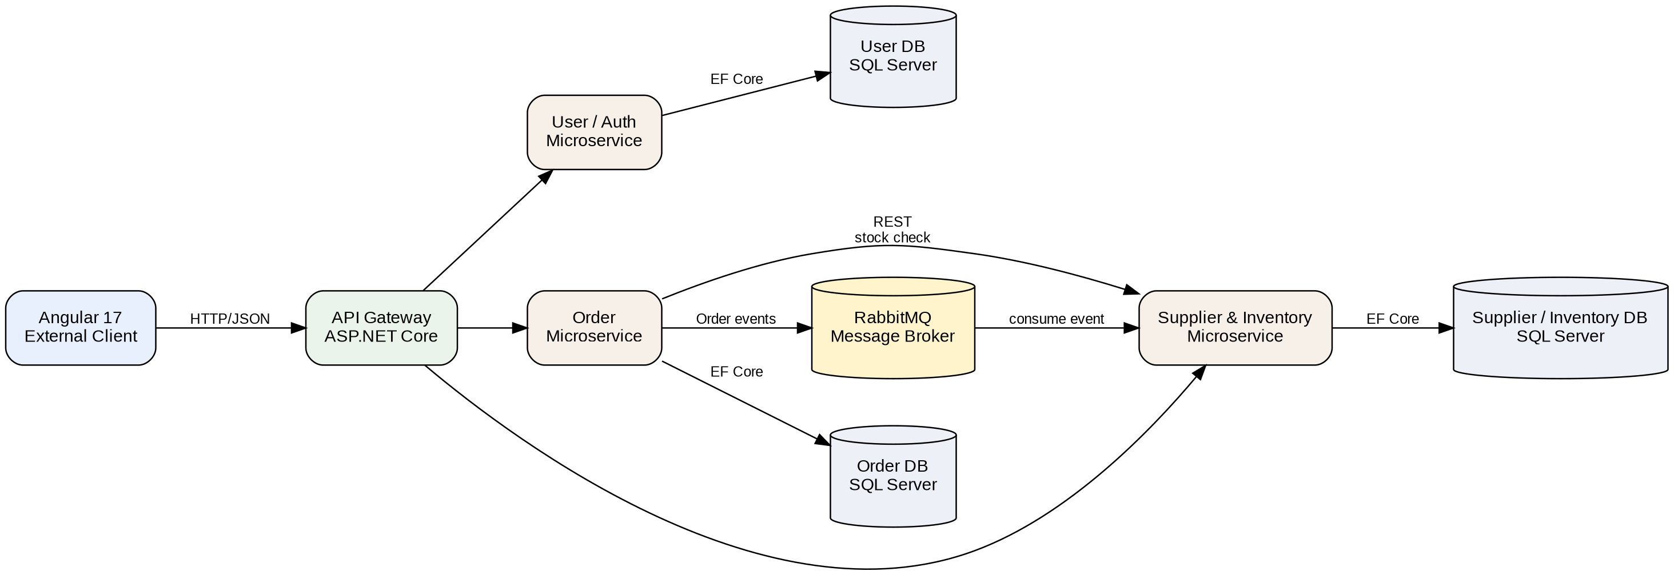

6.0 Solution Steps

6.1 User Registration / Login
1. Client sends registration or login request to the API Gateway.
2. Gateway routes the request to User/Auth Service.
3. User/Auth Service validates the DTO, hashes/checks credentials and persists users through EF Core.
4. On successful login, the service creates a JWT containing user identity and role claims.
5. The token is returned to the client and used on subsequent requests.

6.2 Doctor Views Drugs and Places Order
1. Doctor calls GET /api/drugs through the gateway.
2. Gateway routes the request to Supplier-Inventory Service.
3. Doctor submits POST /api/orders with drug IDs and quantities.
4. Order Service validates the request and calls Supplier-Inventory Service to check stock.
5. Order Service stores Orders and OrderItems in its SQL Server database through EF Core.

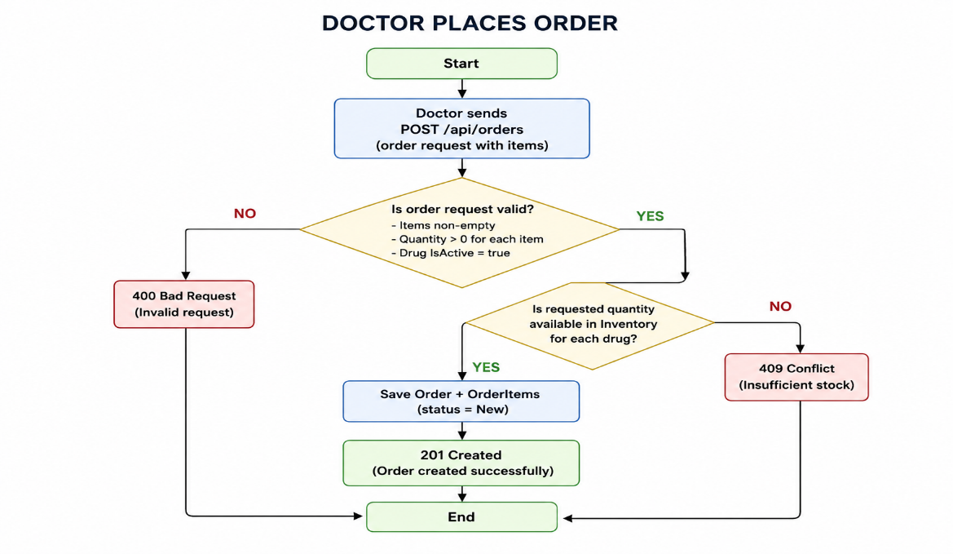
6. The new order is returned with status New.

6.3 Admin Verifies Order
1. Admin calls PUT /api/orders/{id}/verify.
2. Gateway routes the request to Order Service.
3. Order Service verifies that the order exists and is currently New.
4. If valid, the order status changes to Verified.
5. The API returns the updated order status.

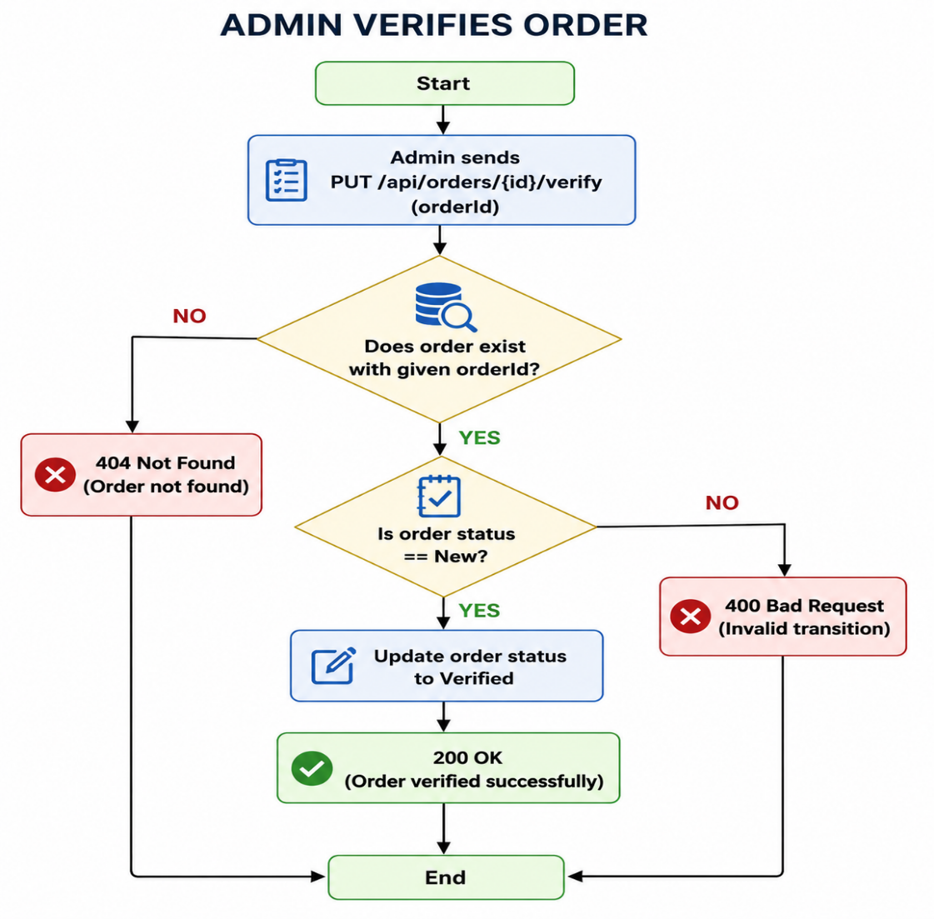

6.4 Admin Marks Order Picked Up
1. Admin calls PUT /api/orders/{id}/pickup.
2. Order Service verifies that the current status is Verified.
3. Order Service publishes an OrderPickedUp event to RabbitMQ.
4. Supplier-Inventory Service consumes the event and reduces stock for each OrderItem.
5. Supplier-Inventory Service creates the Sale record after successful stock update.
6. The Order Service records/completes the pickup state; failures are logged and the event can be retried without directly coupling the services.
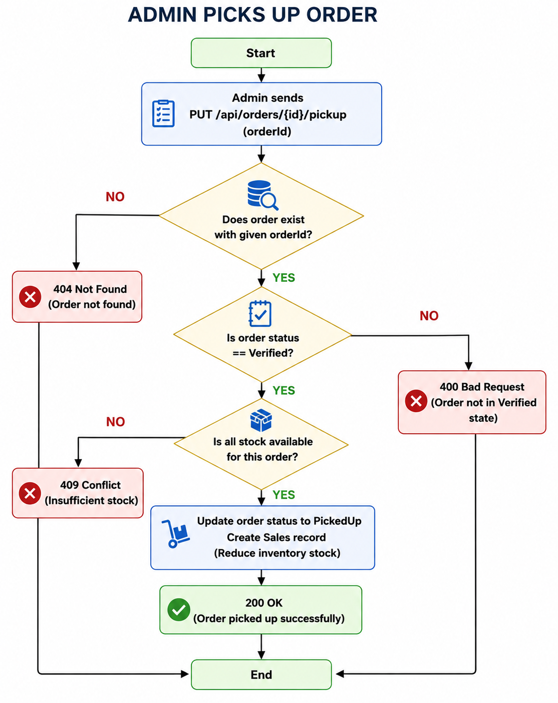

6.5 Sales Report
1. Admin calls the sales-report endpoint with optional date filters.
2. Gateway routes the request to Supplier-Inventory Service.
3. The service queries Sales and returns the requested totals/details.
4. The API returns JSON for viewing and a file/print-ready response for download or print workflows.
Sequence Diagram — Login / Authentication

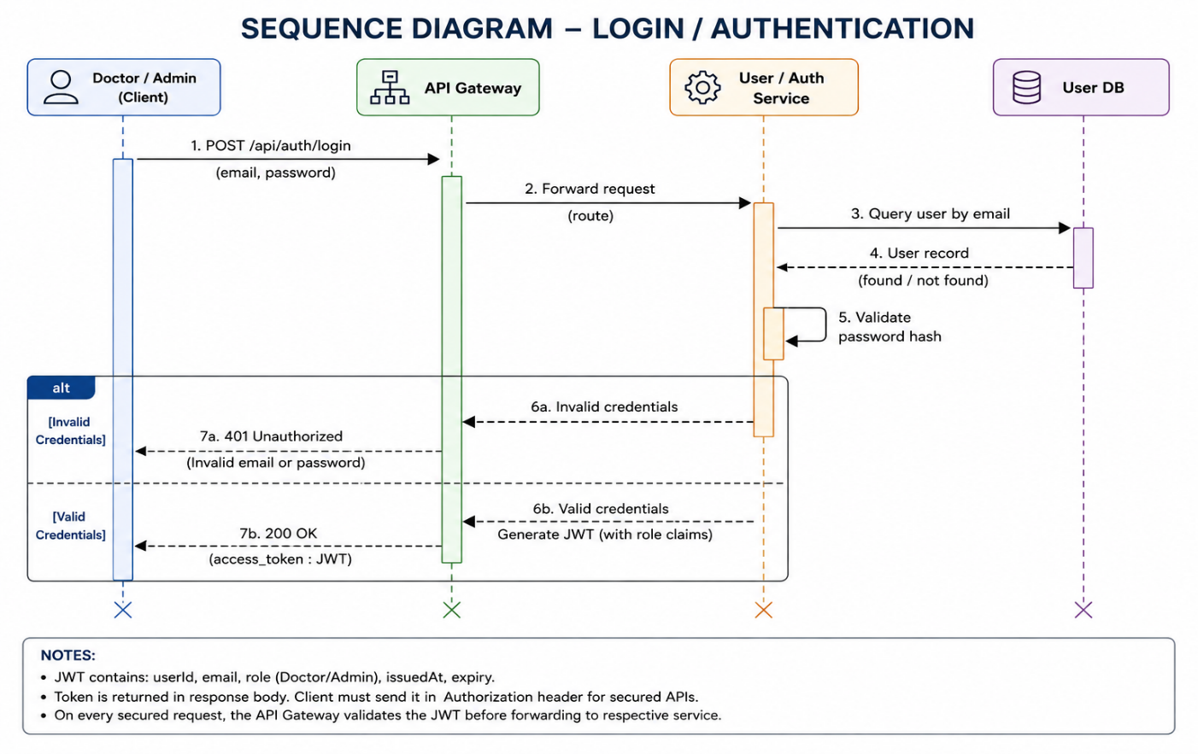

Sequence Diagram — Order Lifecycle

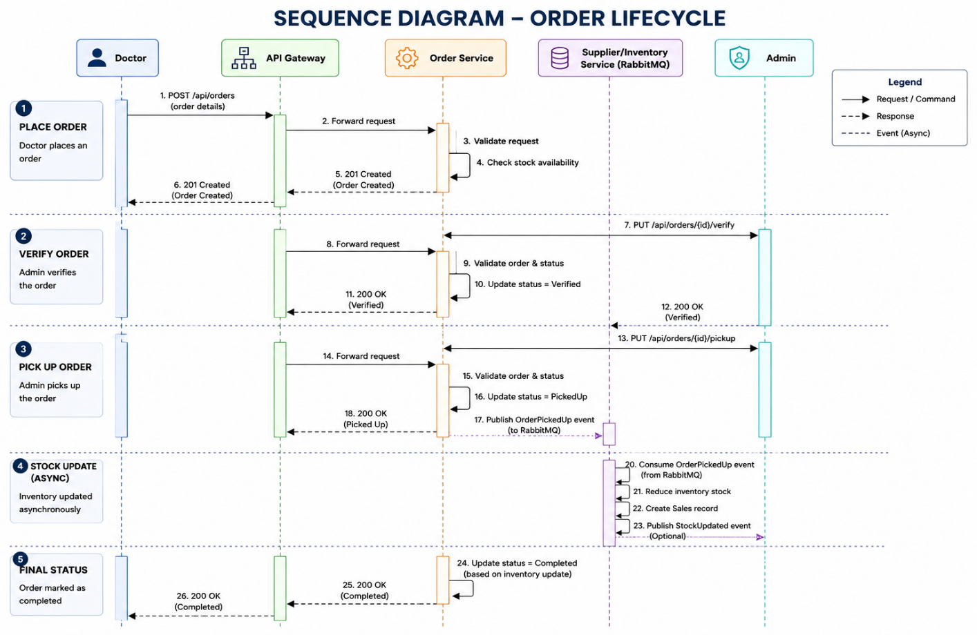
Use Case Diagram

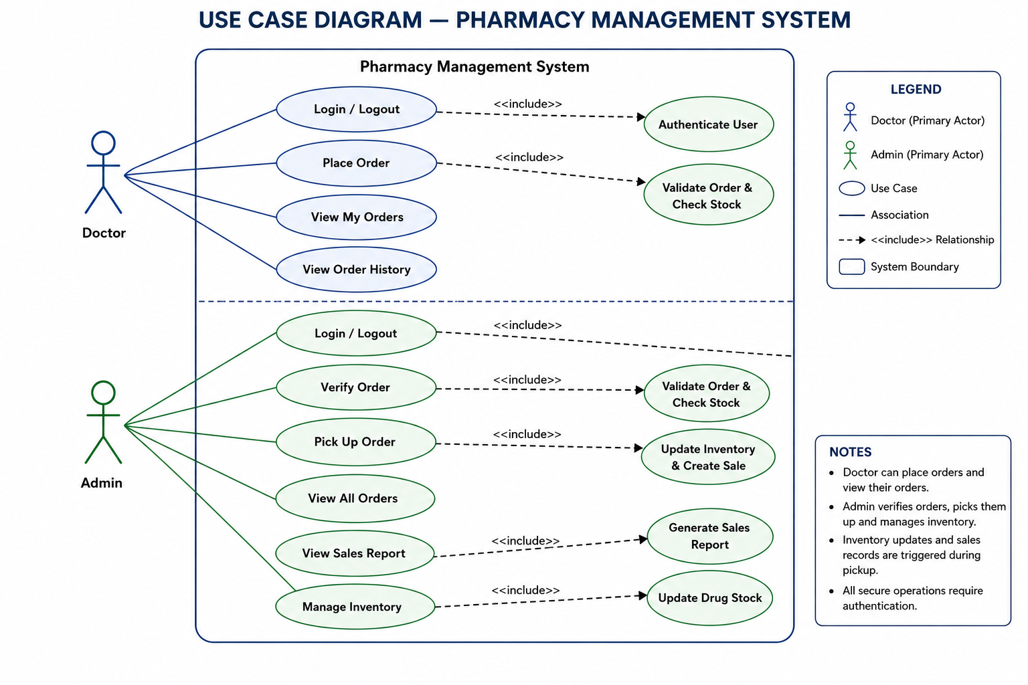

7.0 Classes/function name

Microservice / Layer | Class / Function | Responsibility
User/Auth Controller | AuthController | signup(), login()
User/Auth Service | AuthService | Validate registration/login and create JWT
User/Auth Repository | UserRepository | Read/write User data using EF Core
Order Controller | OrderController | create(), get(), verify(), pickup()
Order Service | OrderService | Order validation, state changes and event publishing
Order Repository | OrderRepository | Read/write Orders and OrderItems
Supplier-Inventory Controller | DrugController | get(), add(), update(), delete()
Supplier-Inventory Controller | SupplierController | get(), add(), update(), delete()
Supplier-Inventory Controller | InventoryController | getInventory()
Supplier-Inventory Service | InventoryService | Stock validation, stock update and sales creation
Supplier-Inventory Service | ReportService | Sales report, download and print data
Common | PharmacyDbContext / service DbContexts | EF Core database access and configuration

User/Auth Service — UML Class Diagram

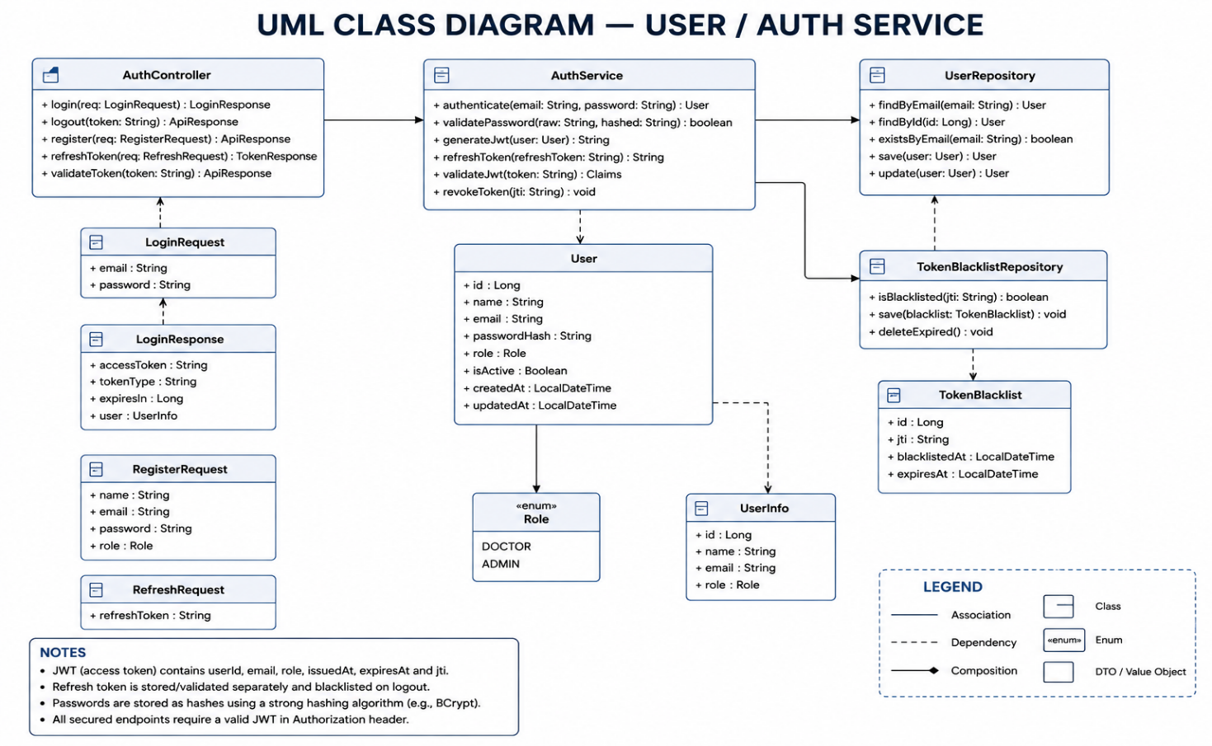

Order Service — UML Class Diagram

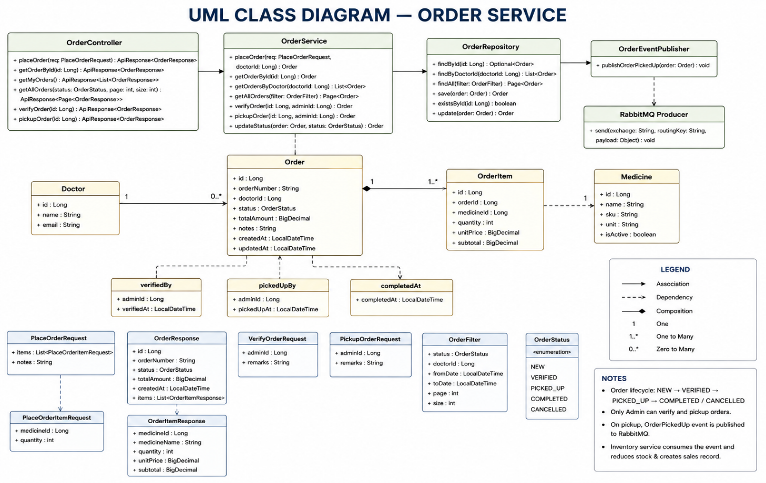
Supplier / Inventory Service — UML Class Diagram

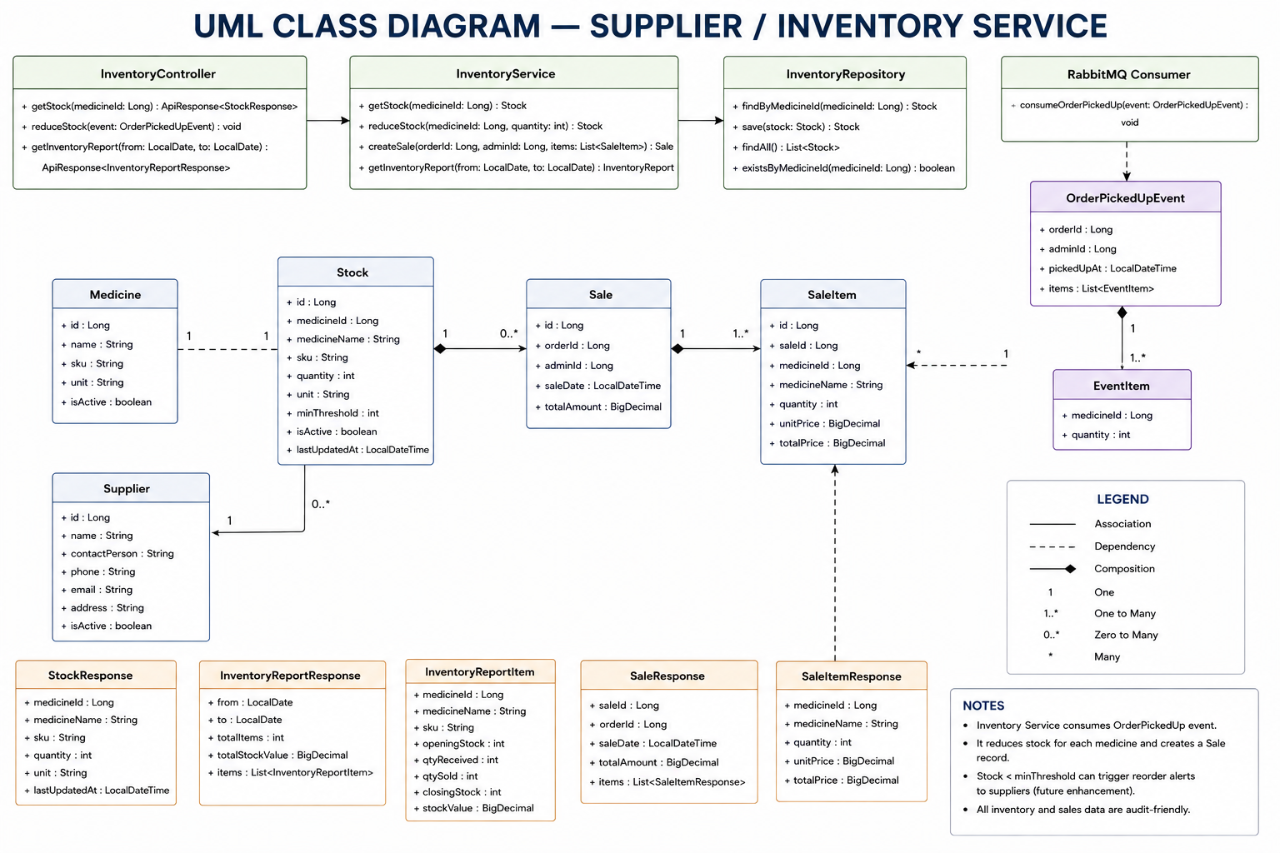

8.0 Validations

Area | Validation
Authentication | Email required and unique; password required; role must be Admin or Doctor.
Drug | Drug name and price required; price must be non-negative.
Supplier | Supplier name and contact/email required.
Order | Doctor role required; at least one item; quantity > 0; drug must be active.
Stock | Requested quantity must be available before an order is accepted.
Verify | Only New orders can be verified; Admin role required.
Pickup | Only Verified orders can be picked up; duplicate pickup must be rejected.
Inventory | Quantity cannot become negative; expired stock cannot be used.
Messaging | OrderPickedUp events must contain a unique OrderId so consumers can safely avoid duplicate processing.

9.0 Data model/Tables

Table | Column | Type | Key / Constraint
Users | UserId | INT | PK, Identity
Users | Name | NVARCHAR(100) | Not Null
Users | Email | NVARCHAR(150) | Unique, Not Null
Users | Contact | NVARCHAR(20) | Not Null
Users | PasswordHash | NVARCHAR(255) | Not Null
Users | Role | NVARCHAR(20) | Admin / Doctor
Drugs | DrugId | INT | PK, Identity
Drugs | DrugName | NVARCHAR(150) | Not Null
Drugs | Price | DECIMAL(10,2) | Not Null, >= 0
Drugs | IsActive | BIT | Not Null
Suppliers | SupplierId | INT | PK, Identity
Suppliers | Name | NVARCHAR(150) | Not Null
Suppliers | Contact | NVARCHAR(20) | Not Null
Suppliers | Email | NVARCHAR(150) | Nullable
Inventory | InventoryId | INT | PK, Identity
Inventory | DrugId | INT | FK → Drugs
Inventory | SupplierId | INT | FK → Suppliers
Inventory | Quantity | INT | Not Null, >= 0
Inventory | ExpiryDate | DATETIME | Not Null
Orders | OrderId | INT | PK, Identity
Orders | DoctorId | INT | Logical reference → User DB; application validation; no DB FK
Orders | Status | NVARCHAR(20) | New / Verified / PickedUp
Orders | TotalAmount | DECIMAL(10,2) | Not Null
Orders | CreatedOn | DATETIME | Not Null
OrderItems | OrderItemId | INT | PK, Identity
OrderItems | OrderId | INT | FK → Orders.OrderId (same Order DB)
OrderItems | DrugId | INT | Logical reference → Supplier-Inventory DB; no DB FK
OrderItems | Quantity | INT | Not Null, > 0
OrderItems | UnitPrice | DECIMAL(10,2) | Not Null
Sales | SaleId | INT | PK, Identity
Sales | OrderId | INT | Logical reference → Order DB; application validation; no DB FK
Sales | Amount | DECIMAL(10,2) | Not Null
Sales | SaleDate | DATETIME | Not Null
E-R Diagram

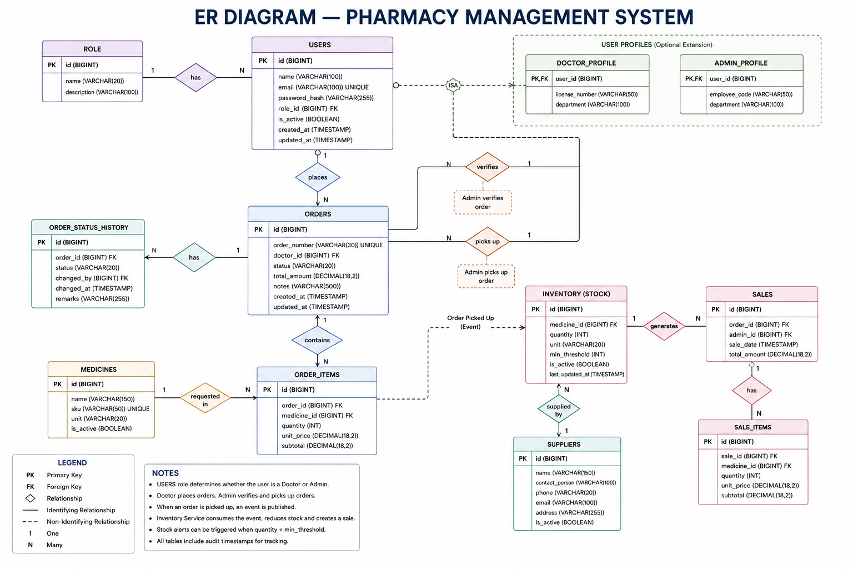

Database Diagram

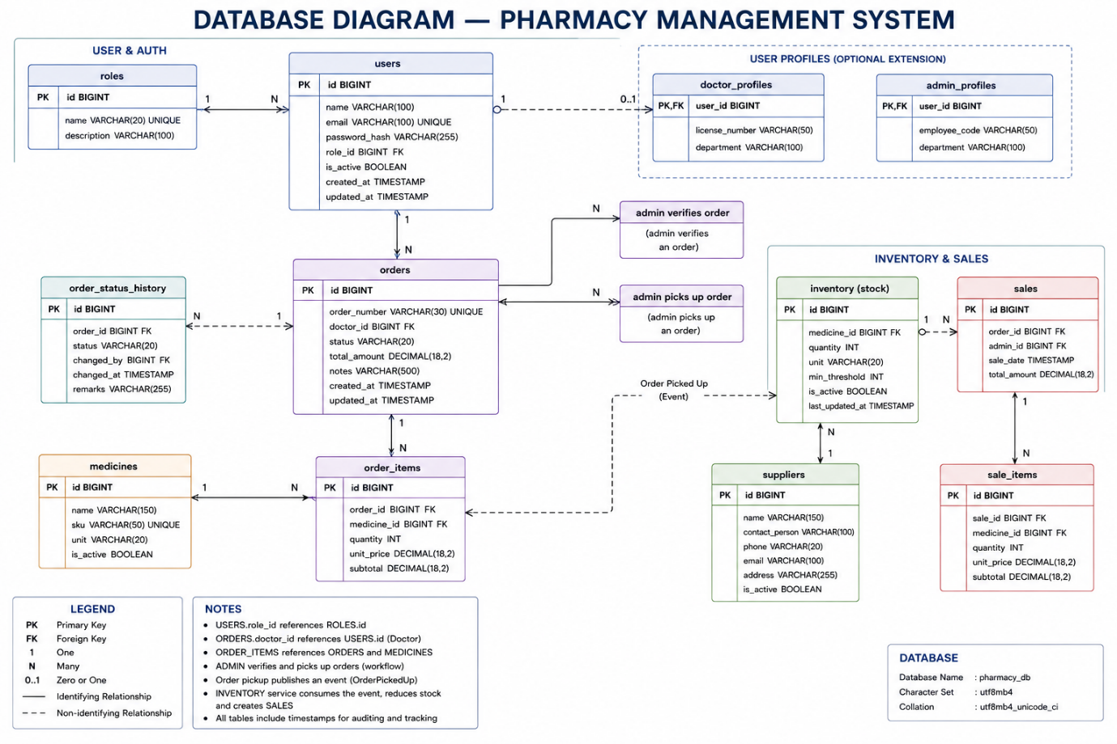
Note: Cross-database references are enforced in application code (service-to-service validation), not database constraints.

10.0 API Canvas

Micro Service | Path | Verb | API Description | Role | Auth
User/Auth | /api/auth/signup | POST | Register user | Admin/Doctor | No
User/Auth | /api/auth/login | POST | Authenticate user | Admin/Doctor | No
Supplier-Inventory | /api/drugs | GET | List active drugs | Admin/Doctor | Yes
Supplier-Inventory | /api/drugs/{id} | GET | Get drug | Admin/Doctor | Yes
Supplier-Inventory | /api/drugs | POST | Add drug | Admin | Yes
Supplier-Inventory | /api/drugs/{id} | PUT | Update drug | Admin | Yes
Supplier-Inventory | /api/drugs/{id} | DELETE | Deactivate drug | Admin | Yes
Supplier-Inventory | /api/suppliers | GET | List suppliers | Admin | Yes
Supplier-Inventory | /api/suppliers | POST | Add supplier | Admin | Yes
Supplier-Inventory | /api/suppliers/{id} | PUT | Update supplier | Admin | Yes
Supplier-Inventory | /api/suppliers/{id} | DELETE | Delete supplier | Admin | Yes
Supplier-Inventory | /api/inventory | GET | View inventory | Admin | Yes
Order | /api/orders | POST | Place order | Doctor | Yes
Order | /api/orders | GET | View doctor orders | Admin | Yes
Order | /api/orders/{id} | GET | Get order details | Admin/Doctor | Yes
Order | /api/orders/{id}/verify | PUT | Verify valid order | Admin | Yes
Order | /api/orders/{id}/pickup | PUT | Mark order picked up | Admin | Yes
Supplier-Inventory | /api/reports/sales | GET | View sales report | Admin | Yes
Supplier-Inventory | /api/reports/sales/download | GET | Download sales report | Admin | Yes
Supplier-Inventory | /api/reports/sales/print | GET | Print-ready sales report | Admin | Yes

11.0 Env variables

Variable | Purpose
USER_DB_CONNECTION | SQL Server connection string for User/Auth Service
ORDER_DB_CONNECTION | SQL Server connection string for Order Service
INVENTORY_DB_CONNECTION | SQL Server connection string for Supplier-Inventory Service
JWT_SECRET | JWT signing secret
JWT_ISSUER | JWT issuer
JWT_AUDIENCE | JWT audience
RABBITMQ_HOST | RabbitMQ host
RABBITMQ_PORT | RabbitMQ port
RABBITMQ_USERNAME | RabbitMQ username
RABBITMQ_PASSWORD | RabbitMQ password

12.0 Integrations

Integration | Purpose
Microsoft SQL Server | Separate relational database per microservice, accessed through Entity Framework Core.
RabbitMQ | Asynchronous messaging for order events such as OrderPickedUp.
JWT | Authentication and role-based authorization.
HTTP/REST/JSON | Synchronous communication between Angular, API Gateway and microservices, including stock checks.

13.0 .NET Hosting / Infrastructure

The backend uses C#, ASP.NET Core 6 Web API and Entity Framework Core. User/Auth, Order and Supplier-Inventory services own separate SQL Server databases. RabbitMQ is hosted separately as the message broker. Angular 17 is an external client and is not part of the backend implementation.

14.0 HTTP Status Code

Code | Meaning | Typical Usage
200 | OK | Successful GET/PUT/report operation
201 | Created | Successful registration or order creation
400 | Bad Request | Validation failure or invalid state transition
401 | Unauthorized | Missing or invalid authentication
403 | Forbidden | Authenticated user lacks required role
404 | Not Found | Requested resource does not exist
409 | Conflict | Duplicate email, duplicate pickup or conflicting state
500 | Internal Server Error | Unexpected server-side error

15.0 Unit Testing

TC ID | Test Case | Expected Result
TC_01 | Valid user registration | 201 Created
TC_02 | Duplicate email registration | 409 Conflict
TC_03 | Valid login | 200 OK with JWT
TC_04 | Doctor creates valid order | 201 Created; status New
TC_05 | Order with insufficient stock | 400/409; order is not created
TC_06 | Admin verifies New order | 200 OK; status Verified
TC_07 | Admin picks up Verified order | 200 OK; OrderPickedUp event published
TC_08 | Inventory consumes pickup event | Stock reduced and Sale created
TC_09 | Duplicate pickup event | No duplicate Sale or stock deduction
TC_10 | Doctor calls Admin-only API | 403 Forbidden
TC_11 | Invalid/expired JWT | 401 Unauthorized
TC_12 | Unknown order ID | 404 Not Found

16.0 Request

16.1 Registration
POST /api/auth/signup
{ "name": "Dr. Kumar", "contact": "9876543210", "email": "doctor@example.com", "password": "Password@123", "role": "Doctor" }

16.2 Login
POST /api/auth/login
{ "email": "doctor@example.com", "password": "Password@123" }

16.3 Add Drug
POST /api/drugs
{ "drugName": "Paracetamol 500mg", "price": 38.25, "description": "Tablet", "isActive": true }

16.4 Place Order
POST /api/orders
{ "items": [{ "drugId": 101, "quantity": 2 }, { "drugId": 205, "quantity": 1 }] }

16.5 Verify Order
PUT /api/orders/1001/verify
{}

16.6 Mark Picked Up
PUT /api/orders/1001/pickup
{}

16.7 Sales Report
GET /api/reports/sales?from=2026-09-01&to=2026-09-30

17.0 Response

17.1 Registration — Success
HTTP 201
{ "message": "User registered successfully", "userId": 501 }

17.2 Login — Success
HTTP 200
{ "token": "<JWT>", "userId": 501, "role": "Doctor" }

17.3 Invalid Input
HTTP 400
{ "message": "Inputs are not valid", "errors": ["quantity must be greater than zero"] }

17.4 Resource Not Found
HTTP 404
{ "message": "Order not found" }

17.5 Unauthorized / Forbidden
HTTP 401
{ "message": "Authentication required" }
HTTP 403
{ "message": "Access denied" }

17.6 Order Created
HTTP 201
{ "orderId": 1001, "status": "New", "totalAmount": 76.50 }

17.7 Order Verified
HTTP 200
{ "orderId": 1001, "status": "Verified", "message": "Order verified successfully" }

17.8 Order Picked Up
HTTP 200
{ "orderId": 1001, "status": "PickedUp", "message": "Order picked up successfully" }

17.9 Unexpected Error
HTTP 500
{ "message": "Internal server error" }

